##### **Java Mission Control**

[Java Mission Control (JMC)](https://docs.oracle.com/javase/8/docs/technotes/guides/troubleshoot/tooldescr002.html" \l "BABIBBDE" \t "https://lms.antra.com/main/course/_blank)

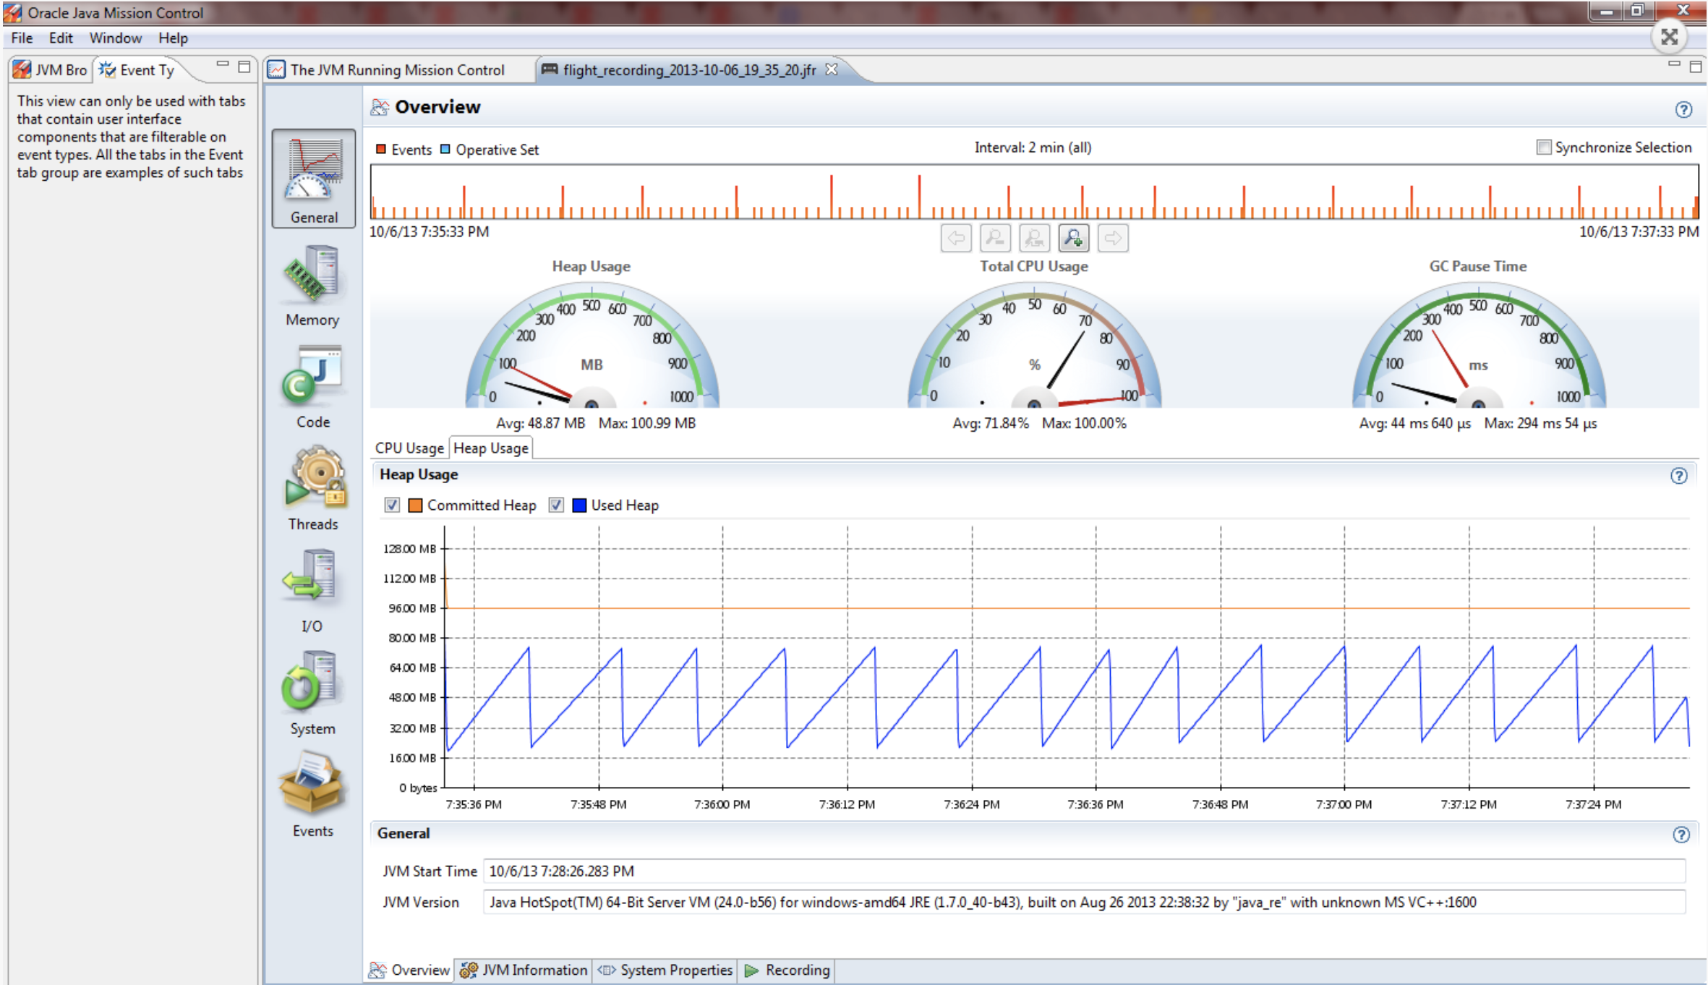

##### **Java VisualVM**

[Java VisualVM](https://docs.oracle.com/javase/8/docs/technotes/guides/troubleshoot/tooldescr010.html" \l "BABEEIFH" \t "https://lms.antra.com/main/course/_blank)

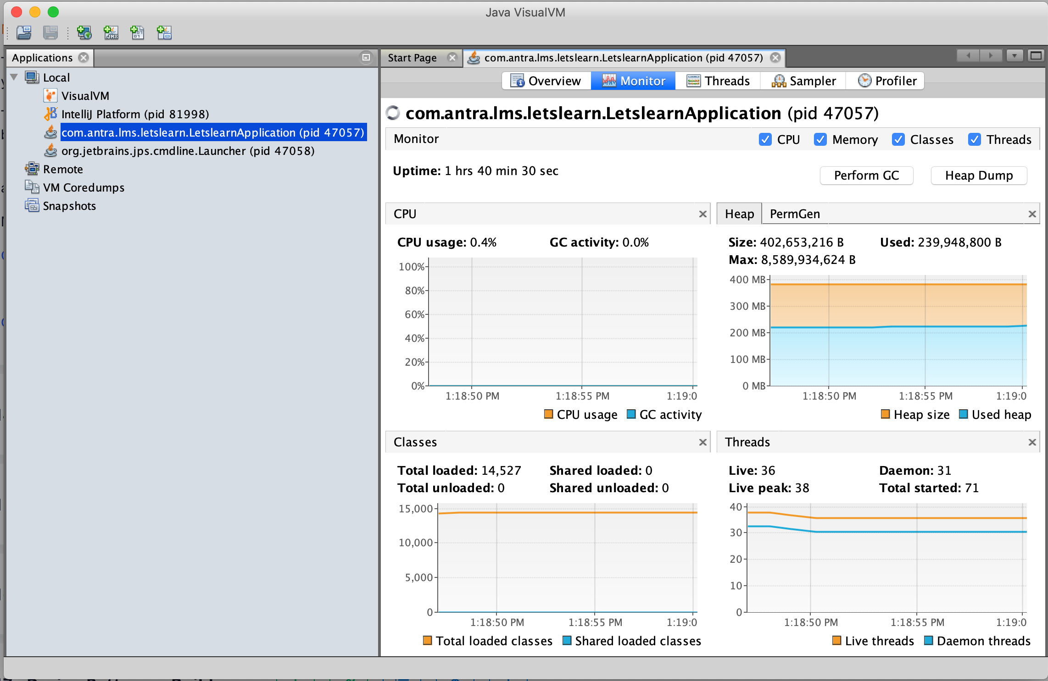

##### **JConsole**

[JConsole](https://docs.oracle.com/javase/8/docs/technotes/guides/troubleshoot/tooldescr009.html" \l "BABDCICF)

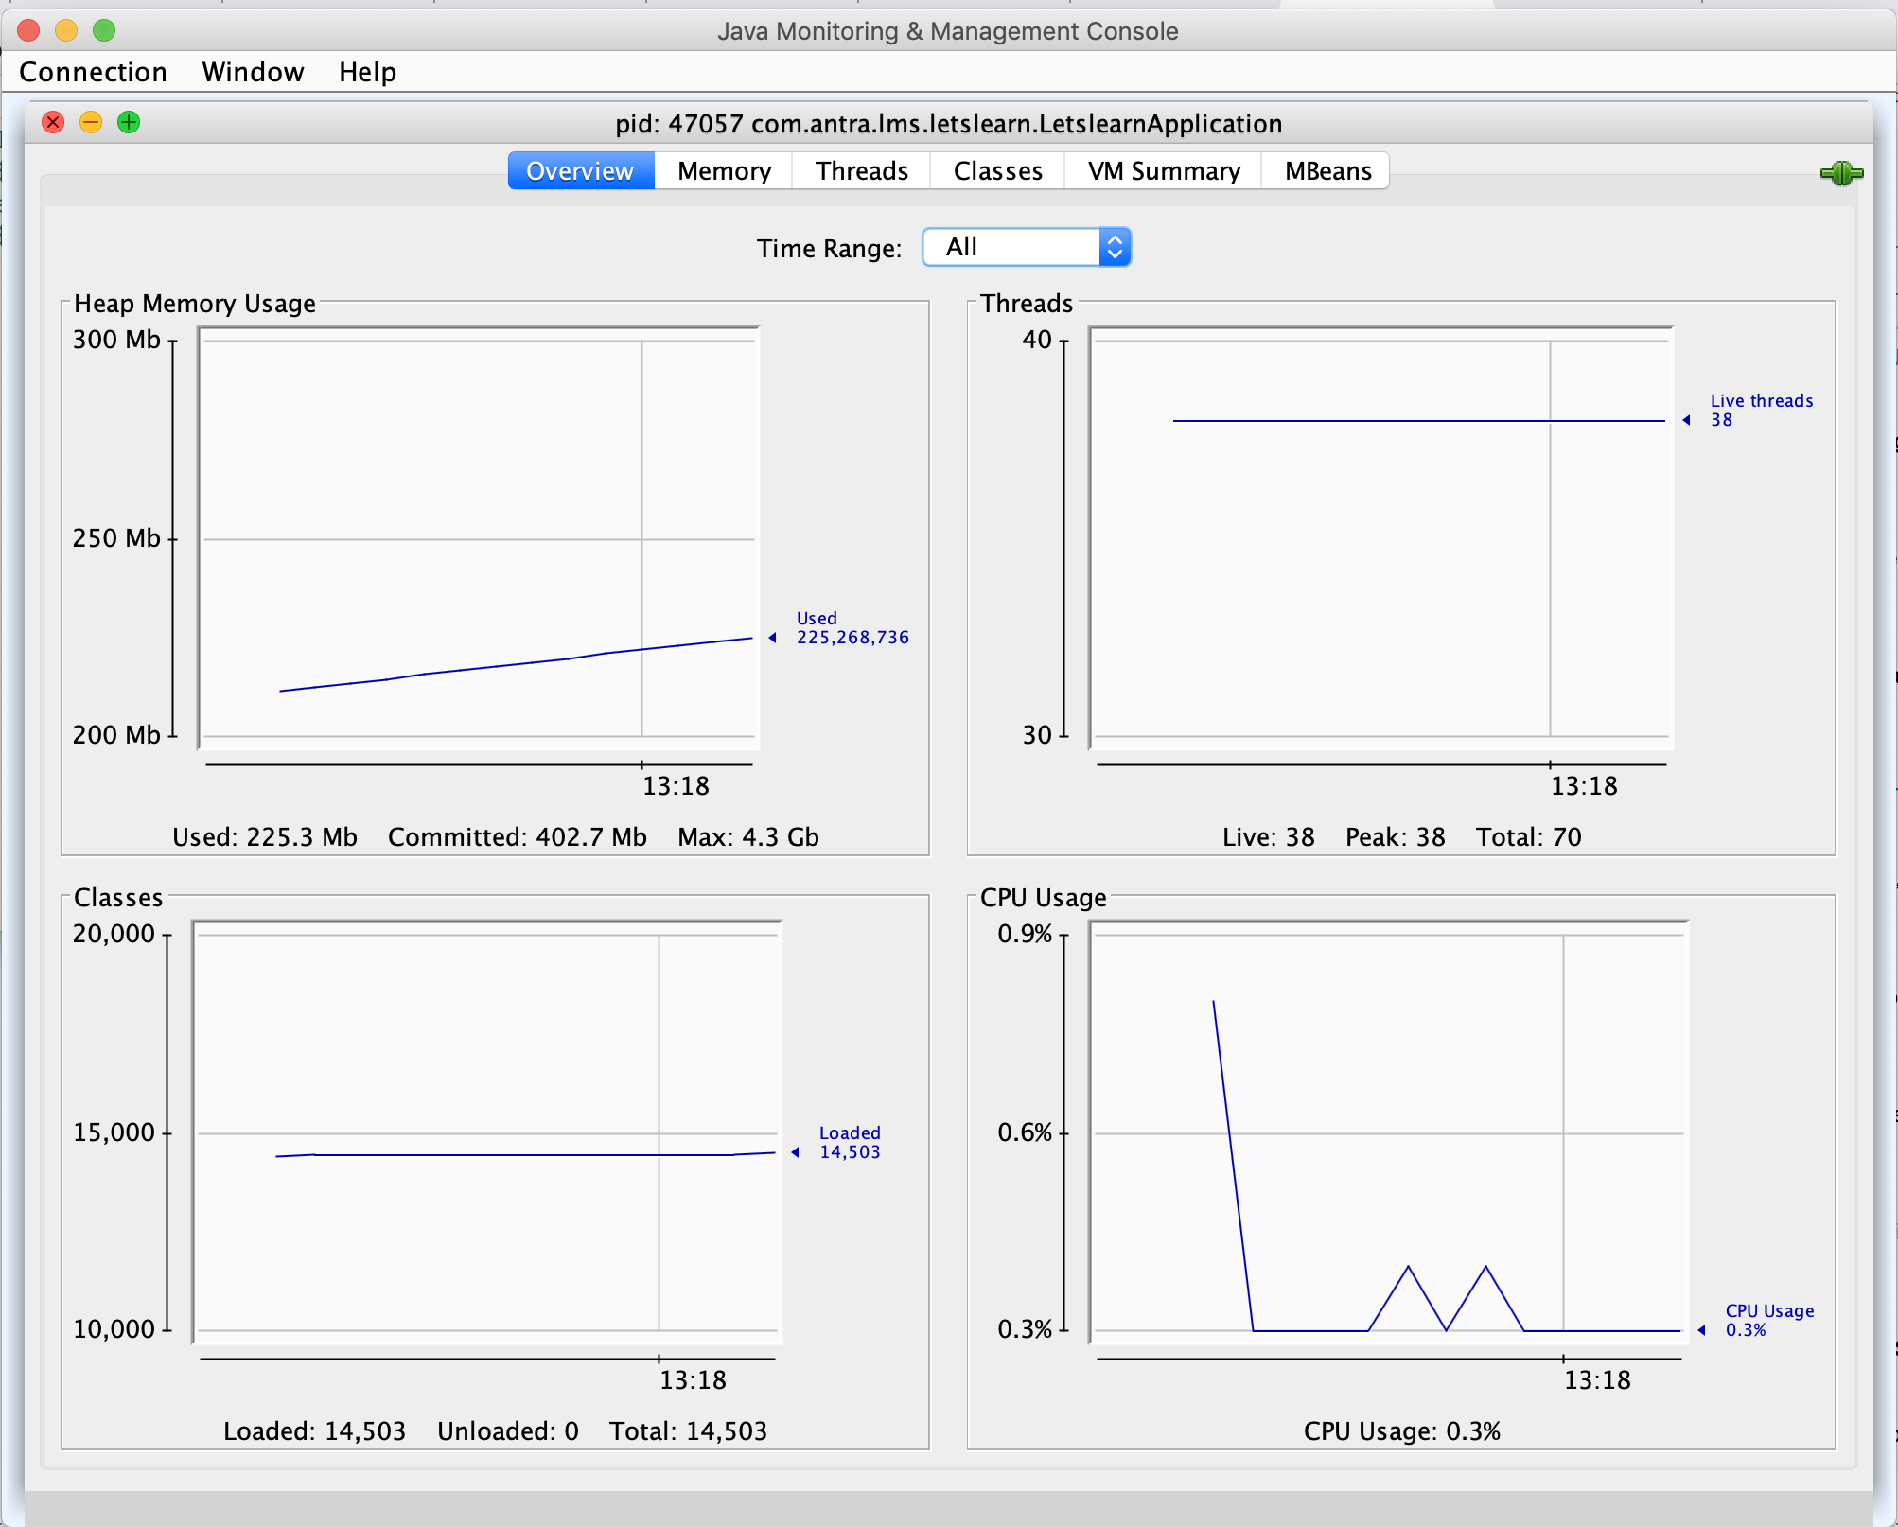

In command line, run 'jmc' or 'jconsole' or 'jvisualvm'  for the tools.

Java Mission Control is the recommended one by Oracle.

Jconsole is the oldest one.

All of them can provide information of JVM based on JMX. Information such as Memory/CPU usage, I/O, Threads, Classes, Methods and Objects.